Justin’s Literature Review

1. **Aircraft Type Recognition Based on Target Track**

* Summary: The motivation of this research study was to develop an image recognition approach using machine learning to capture detailed pieces of information in real-time and to identify potential patterns from datasets collected during flyover that can replace the standard, and inefficient graphic image processing technique. The team used a novel supervised machine learning classification model that reads in input from in-flight sensor data such as cruise speed, climb rate, pressure, temperature, and other ambient properties. A schematic that details the black-box diagram for this image recognition system is shown below. Here, the machine learning classification algorithm reads in data in real time from in-flight sensors, and uses the data to classify aircraft vehicles of different types. For our project, we could use this general framework where inputs from in-flight sensor data are read into a machine learning algorithm that is trained specifically to the features of the targets of interest as well as any surrounding environmental features (trees, standing water, fields, etc.) to classify the TOIs

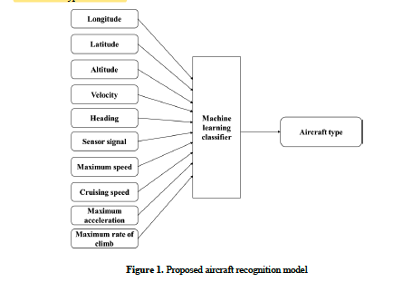

1. **Flight Tests of Autopilot Integrated with Fault-Tolerant Control of a Small Fixed-Wing UAV**

* Summary: A fault-tolerant flight control system based on Pixhawk for a small fixed-wing UAV is designed to control the UAV flight behavior with high performance against the sensor failure. Below is a subsystem diagram of a UAV hardware system which includes communications between ground control station and autopilot mechanism.

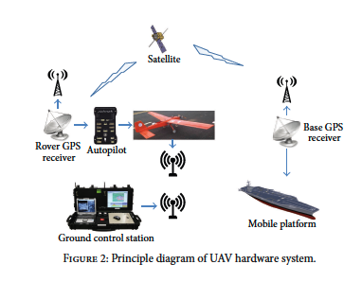

Notes: The original flight control software of Pixhark is Arduplane which is an open-source UAV platform that is able to control autonomous aircrafts. It may be worth time researching the use-case of this software for our UAV, and how we can integrate it into the autopilot and co-processor hardware.

1. **PIXHAWK: A micro aerial vehicle design for autonomous flight using onboard computer vision**

* Summary: The research team describes a novel quadrotor Micro Air Vehicle

(MAV) system that is designed to use computer vision

algorithms within the flight control loop for autonomous flight. The PIXHAWK design includes a powerful onboard computer which makes it possible to run high-level tasks, in particular visual localization, onboard the MAV.

1. **SAR Automatic Target Recognition Using Discriminative Graphical Models**

* **Motivation:** Although ATR systems have increased in applicability and accuracy over the last several decades, there exist two predominant challenges to incorporating efficient ATR systems. Namely, the advantage of combining the most important features from two or more feature sets in an ATR algorithm to pull more details from images (feature fusion), and designing, and ultimately, training, an ATR classifier algorithm using images of limited quantity and/or poor resolution. Motivated by these two challenges, Raj and his associates developed a prototype for an ATR framework using discriminatively learned graphical models that incorporate the concept of feature fusion, and minimizes reductions in accurate feature detection due to limited training data and imagery. These ATR algorithms were designed to be compatible with SAR (synthetic aperture radar) imagery which is a form of radar used to create image reconstructions of objects by leveraging the motion of a radar antenna over a target region.
* **Background of Image Classification Techniques**

The overarching challenge to designing effective image classification algorithms is to incorporate features that allow for the algorithm to classify images into separate classes according to their features. In the real-world, there are many obstacles and deviations from ideal ambient behavior that the image recognition algorithm must account for during the classification. Examples of such obstacles include:

1. **Variation in atmospheric properties**

Ex: (light intensity, transparency/opaqueness, temperature, pressure, cross winds, precipitation)

The image recognition algorithm should be trained to account for a practical range of deviations in these atmospheric properties from their ideal values to account for uncontrollable external flight parameters

1. **Orientation and Kinematics of Unmanned Aircraft System**

Quantity of important information captured in images/reconstructed through radar signals and their associated resolution depends on the orientation of UAS and potentially field of vision of imaging equipment.

1. **Sensitivity and Reliability of instrumentation**

* Sensors, actuators, and other forms of measurement devices that are reading ambient flight conditions that could impact the resolution and classification of imagery must be properly calibrated, and checked for accuracy and reliability. It is desirable to read these measurements into the ATR algorithm as part of the image classification process in real-time, so inconsistent/inaccurate readings could impact the target classification greatly

Although there has been a lot of evolution in image classification techniques, the consensus in the literature is that there is no “industry-standard” ATR engine/system that is optimal for target recognition.

* **Research Team’s Discriminative Graphical Model Prototype**

The research team developed a two-stage framework for designing a discriminative graphical model for ATR shown in the figure below:

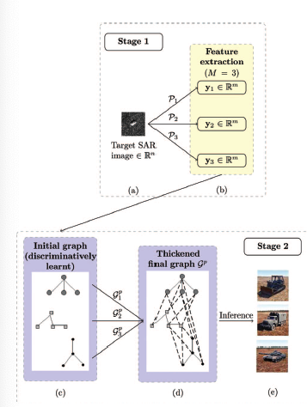

The first procedure of the algorithm involves loading a training target image into the workspace and performing a feature extraction. The feature extraction is accomplished by executing vector projections of the image onto a lower dimensional space. Once vectors of the image data have been projected, a sparse graph is constructed from the vectors using a series of nodes. Then, images are assembled from individual partitions of the low dimensional space that correspond to small partitions of the original image. A discriminatory tree algorithm that incorporates statistical concepts such as probability density functions and confidence intervals, then compares each of these small partitions of the reconstruction of the target image from this low dimensional space to equal sized partitions of the actual target image. Once these disjoint trees/image partitions have been assembled and iterated for optimized reconstruction according to the aforementioned statistical properties, a feature fusion algorithm is applied to integrate the disjoint trees together into until a reconstruction is reached that provides a near perfect representation of the original image as we see in parts (d) and (e) respectively.

* **Conclusion**

In conclusion, the research team determined that their discriminative graphical ATR system was very effective in classifying target images in applications where there were a low quantity of available images to train the system.

* **Application of ATR Techniques to Our Project**

The results of this research study are applicable to our objectives in developing an automated target recognition system as we likely be operating off of high-dimensional image data, and be somewhat restricted to the amount of training images that we can acquire from the flyover area of interest to train our models.

1. **Robust automatic target recognition using learning classifier systems**

**References**

1. Honglan Huang et al 2018 J. Phys.: Conf. Ser. 1061 012015
2. Wang, Shuo, et al. “Flight Tests of Autopilot Integrated with Fault-Tolerant Control of a Small Fixed-Wing UAV.” *Hindawi*, Hindawi Publishing Corporation, 15 June 2016, https://www.hindawi.com/journals/mpe/2016/2141482/.
3. Meler, Lorenz, et al. “PIXHAWK: A Micro Aerial Vehicle Design for Autonomous Flight Using Onboard Computer Vision.” *SpringerLink*, Springer Science+Business Media, LLC, 23 Feb. 2012, https://link.springer.com/article/10.1007/s10514-012-9281-4.
4. Srinivas, Umamahesh, et al. “SAR Automatic Target Recognition Using Discriminative Graphical Models.” *Institute of Electrical and Electronics Engineers*, Office of Naval Research, 2 May 2014, https://ieeexplore-ieee-org.ezproxy.lib.utexas.edu/stamp/stamp.jsp?tp=&arnumber=6809937.